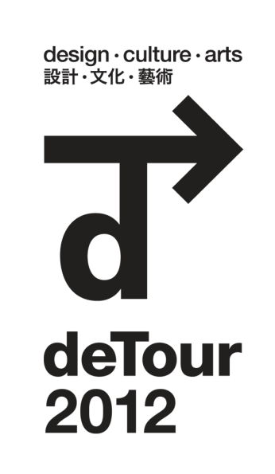 | OPEN CALL FOR SATELLITE EVENTS  About DETOUR  Established in 2006, DETOUR is the annual flagship program of Hong Kong Ambassadors of Design, aimed at showcasing Hong Kong as a regional creative hub and featuring inspiring designs from Hong Kong's young and emerging creative talent.  To have your event* included in the DETOUR 2012 programme booklet, please fill out the information below in English and Chinese return and before Friday, 12 October 2012.  * Applicable only to events happening between 30 November to 16 December 2012

Required fields in Bold.
Event Name:
Event Dates:
Event Venue and Address:
Event Time (Opening Hours):
Contact Person Name:
Phone:
Email:
Event Description
(80-100 words):
Event Website:
Mailing Address:
Estimated number of visitors/attendants:

Please provide an image for possible inclusion.
(exhibition or profile related / 300 dpi / printable size no less than 200mm x 200mm)

For more information about Satellite Events Listings at DETOUR 2012, please contact Cherry Chan via email at cherry.chan@ambassadors.org.hk or call 2739 6889.

粗體項目必須填寫。
活動名稱:
活動日期:
活動地點及地址:
活動時間 (開放時間):
聯絡人姓名:
聯絡電話:
聯絡電郵:
活動內容 (80-100 字):
活動網址:
郵寄地址:
預計觀眾/參加者人數:

請提供相關活動相片:
(展覽或藝術家相片 / 300 dpi / 印刷尺寸不少於 200mm x 200mm)

如欲查詢有關DETOUR 2012 Satellite Events 之詳情, 請電郵cherry.chan@ambassadors.org.hk 或致電 2739 6889聯絡Cherry Chan。

